Direct diagnosis of cutaneous leishmaniasis of skin lesion specimens by PCR and evaluate the sensitivity of testing methods in Wasit Province
Altamemy, A.K. Aakool
التشخيص المباشر لطفيلي الليشمانيا الجلدية من نماذج الافة الجلدية باستعمال تقنية تفاعل سلسلة البلمرة وتقييم حساسية طرق الاختبار في محافظة واسط

م.د.عبد الكريم عاكول ربيع التميمي
الخلاصة
نفذت هذه الدراسة لتشخيص الطفيلي الذي يسبب الليشمانيا الجلدية باستعمال بادئين خاصة بتحديد الجنس والنوع ‘ جمعت عشرة نماذج من الأفة الجلدية لأشخاص يحتمل اصابتهم بطفيلي اللشمانيا الجلدية وبأعمار مختلفة من الذكور والاناث . حضرت هذه النماذج على اقراص صغيرة من اوراق الترشيح لغرض استعمالها في اختبارات تفاعل سلسلة البلمرة (PCR ) باستعمال بادئين مختلفين . الاختبار الاول يسمى spliced leader mini-exon polymerase chain reaction (SLME PCR) لتحديد جنس طفيلي اللشمانيا بشكل عام وكانت النتيجة موجبة لجميع النماذج العشرة وحسب الوزن الجزيئي وكان 89 زوج قاعدي لأربع نماذج منها اما النماذج الست الاخرى فكان الوزن الجزيئي لها 100 زوج قاعدي و كانت حساسية هذا الاختبار (100%) ، وعند استعمال البادئ الثاني B6 الخاص بتحديد نوع طفيلي الليشمانيا المدارية فقط ( L. tropica ) ظهرت ستة حالات موجبة من اصل عشرة على انها ( L. tropica ) وحسب الوزن الجزيئي للحمض النووي للطفيلي و كان 359 - 360 زوج قاعدي وهذا يشير الى ان النماذج الاربعة الاخرى هي من النوع (L. major ) وذلك لوجود هذين النوعين فقط في العراق. أظهر الفحص المجهري لشرائح مصبوغة بصبغة الكمزا من الأفة الجلدية أن النتيجة موجبة في ثمانية حالات ( الحساسية 80%) عند ملاحظة الطفيلي (الطور عديم السوط) داخل الخلايا البلعمية. وعند زراعة عينات من الأفة الجلدية في الوسط الزرعي شبه الصلب وعلى درجة حرارة 26 º م , لوحظ وجود طفيلي الليشمانيا بطور امامي السوط في ثمان حالات ايضا (الحساسية 80%).

ABSTRACT
The study had been conducted to diagnose the parasite that cause cutaneous leishmaniasis by using two specific primer , ten samples from cutaneous lesions ( expected to be cutaneous leishmaniasis) were collected from different ages males and females , some of sample spotted onto filter disks were punched out with a paper puncher (two disks per sample) to be used in the polymerase chain reaction (PCR) by using two different primers, the first was spliced leader mini-exon polymerase chain reaction (SLME PCR) used to idetify Leishmania parasites genus according to molecular weight, there are four samples with DNA bands molecular weight 89 bp and the other six samples with 100 bp. The sensitivity of this test was 100%. The second primer ( B6) is a specific primer that used to identify parasite species. Six samples of ten was positive and the molecular weight of DNA bands ranging from 359 – 360 bp, this refer to L. tropica, so the other four samples may be L. major because only two species of cutaneous leishmaniasis regionally prevalence in Iraq.
Microscopic slides were prepared from the cutaneous lesion, stained by giemsa stain, the slides showed only eight cases positive by detecting the amastigotes in macrophages, so the sensitivity of this test was 80%. Samples of cutaneous lesion also cultured in a semi-solid culture medium and incubated at 26˚c , it had been noticed that there is Leishmania parasite in promastigote phase in eight of ten samples, the sensitivity of this test was 80%.

INTRODUCTION
Leishmaniasis is a zoonotic and anthroponotic disease, endemic in tropical and subtropical areas of the world, is caused by parasitic protozoa of the genus Leishmania. It is is a major public health problem with 1.5–2 million new cases annually and with up to 350 million people at risk in the world (1).
Leishmaniasis occurs in three major clinical forms: cutaneous leishmaniasis (CL), mucocutaneous leishmaniasis (MCL) and visceral leishmaniasis (VL). Many of them are responsible for a wide spectrum of clinical symptoms and signs in the world, selection of appropriate treatment and reduces its complications depend on correct diagnosis of the disease; frequently, Leishmania species are identified based on their geographical distribution and on clinical manifestations of the resulting disease. (2).
As the symptoms of leishmaniasis can vary and may be confused with other etiologic agents, diagnostic confirmation of the parasite is mandatory.
Direct detection of Leishmania parasites by microscopic examination from clinical samples or by culturing is done. Morphologically, all Leishmania species are very similar and species identification is not possible using either of these techniques.
In general, the disease diagnosis is accomplished by demonstration the parasite directly by microscopic examination of stained specimens, by isolation of the parasite from tissue in suitable culture and immunological methods by detection of parasite antigens and antibodies to the parasite (3).
However Isoenzyme analysis is the gold standard for the differentiation and identification of Leishmania species but methods require massive amounts of parasites obtained from cultures, trained technicians and reference laboratories, conditions not available in endemic areas and also the ability to distinguish among Leishmania is crucial when proscribing treatment, as well as in epidemiologic studies to determine possible control measures (4).
The Cutaneous lesion of CL is clinically similar to other skin diseases, various techniques have been used to diagnose its agent in affected lesions (5). A varied symptoms due to CL with different species is a difficult diagnosis by classical laboratory diagnosis methods such as examination of skin lesions by staining smears, histo-pathological examinations and cultures are highly specific but its low and variable sensitivity (6).
In addition to, time consuming, requiring experienced technicians and species of Leishmania parasite cannot identify.
Recently, Polymerase chain reaction (PCR) have proven to be highly sensitive and specific compared with standard methods and are considered valuable for leishmaniasis diagnosis (7, 8, 9).
In the past two recent decades a few number of (PCR) assay were used for improving the detection and characterization of Leishmania spp throughout amplifying different repeated sequences, including ribosomal (10), mini-exon and mini/maxi-circle kDNA, (11).
The best advantages of PCR-based methods are the high ability for detection of low amount of Leishmania DNA in a variety of clinical samples, such as skin biopsy, blood, bone marrow.
The aim of this study is a rapid diagnosis and parasite species detection directly from skin lesion of cutaneous leishmaniasis.
MATERIALS AND METHODS
Samples collection
Ten samples of skin lesion from suspected cutaneous leishmaniasis cases were collected from patient (10-18) years old in Wasit Province (Al-Zehraa hospital), the lesion with diameter 0.5 – 4 cm , (figure 1). The duration of infection ranged from 30 – 60 days. The aspirated fluid obtained from lesions was divided to prepare staining microscopic slides and some of sample spotted onto filter disks were punched out with a paper puncher (two disks per sample). After each sample was obtained a clean sheet of paper was punched 10 times in order to prevent DNA contamination from one sample to the next (13), and some of sample cultured in semisolid medium, it was incubated in cool incubator at 26˚c to detect the parasite promastigotes.
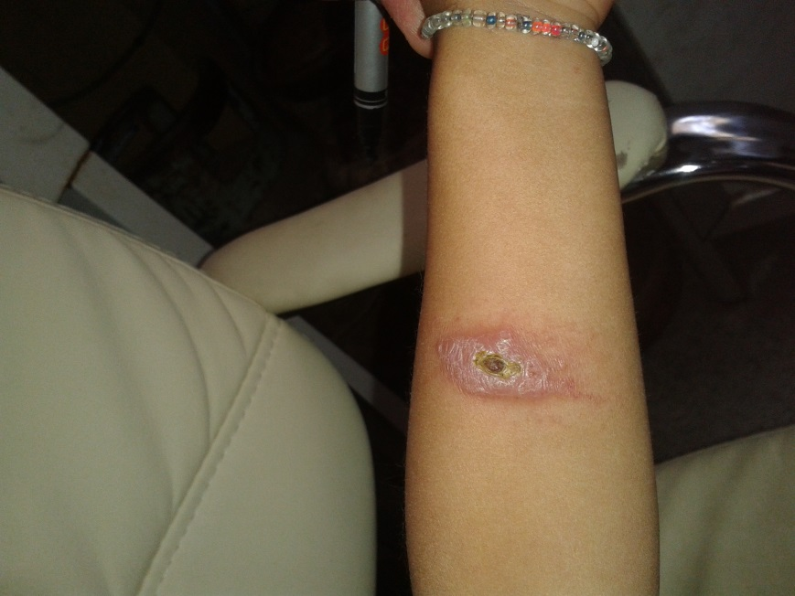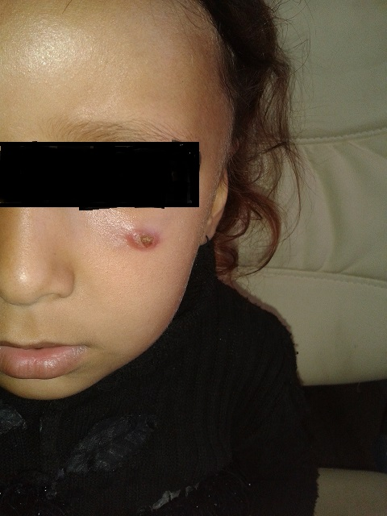
Figure (1) skin lesion of patient infected with cutaneous leishmaniasis
Preparation of staining smears
From aspirates of lesion chancer spread on cleaning glass slide, fixed with alcohol methanol for one minutes and staining with 1% Giemsa stain solution overnight to detect Leishman Donovan bodies (LD bodies). From each sample prepare two slide, one of them staining and the other covering with cover slip to use in PCR assay.
Semisolid medium
This medium used to isolate parasite from skin lesion of infected host and it considered very suitable to isolate and preserved parasite in-vitro, its components was listed in table (1).
Table (1) The components of semisolid medium (100 ml)
691 mg | NaCl | 1
29 mg | KCl | 2
10 mg | NaHCO₃ | 3
22 mg | CaCl₂ H₂O | 4
77 mg | D- Glucose | 5
100 mg | Peptone | 6
400 mg | Agar agar | 7
30 mg | beef extract with agar | 8
50 mg | Gentamycin | 9
80 ml | Distilled water | 10
20 ml | Rabbit Defibrinated blood | 11

The medium was prepared according to (12) and divided to 10 ml in each sterilized universal tube and incubated at 37 ○C for 24 hours to ensure free from contamination then stored in a refrigerator at 4 ○C.
DNA extraction
The DNA was extracted according to technical manual of Provider Company (Promega Canada).
The samples that spotted onto filter disks previously were placed into 250 µL lysis buffer (13, 14). Cell lysis with all samples was accomplished after incubation for at least 3 h or overnight at 56°C. The DNA pellets were dried using a speed vacuum dryer (Concentrator 5301, Eppendorf) for 5 min and re-dissolved in 50 µL TE buffer (10 mM Tris and 1 mM EDTA, pH 8,0). The samples were kept at 4°C until assayed.

Polymerase Chain Reaction (PCR)
Each sample was analyzed using two different pairs of PCR primers (Promega). The sensitivity of each PCR was optimized on pure Leishmania DNA prior to use for diagnosis. The Spliced Leader Mini-Exon Polymerase Chain Reaction (SLME PCR) assay was carried out according to (15), using the forward primer, Fme (5′-TAT TGG TAT GCG AAA CTT CCG-3′) and reverse, Rme (5′-ACA GAA ACT GAT ACT TAT ATA GCG-3′), that target the mini-exon gene present as tandem repeats in all species of the Leishmania genus were used. In order to optimize the reaction, 75 mM KCl and 2.5 U Taq polymerase were added.
The second step of PCR was performed using L. tropica species specific primers B6 (Forward GCTCTGCCCACGCACACACAG) and B6 (Revers CGGTGCCTGCCAAGTA).The PCR was performed according to (16) in 25 µl reaction solution consisting 12.5 µl of green master mixture (Promega), 1.5 µl 1.5pmoles of each primer, 1.5 µl of free nuclease deionized distil water, and 8 µl of each samples as DNA template. Cycling was performed in a thermocycler (MULTIGENE _{Labnet}) with the following conditions: an initial denaturation step at 5 min at 94○C.
followed by 30 cycles, each consisting of 30 s at 94 ○C, 30 s at 68○C, and 30 s at 72○C, and a final extension of 10 min at 72○C.
PCR products were detected by electrophoresis in 1% agarose at 80 V in the presence of ethidium bromide.
RESULTS AND DISCUSSION
The result of Diagnosis in this study revealed that the ten samples of skin lesion ( suspected to be cutaneous leishmaniasis) that tested by the spliced leader mini-exon polymerase chain reaction (SLME PCR) assay, elucidates the existence of DNA bands fragment in gel electrophoresis stained with ethidium bromide obtained from samples, ( figure 2).
The species of Leishmania that recorded in patient of wasit province (Iraq) were only Leishmania tropica and L. major prevalence (17), this assay is targeted to the multi-copy spliced leader mini-exon gene repeats of Leishmania parasites and this assay is specific to the Leishmania genus and does not recognize related kinetoplastid protozoa ( 18 ). The band that detected in this assay refer to the positive results of all samples. The molecular weights of amplicon was demonstrated by using gelanalyzer 2010a software (figure 3). It was different and ranging in molecular weight from 89 base pair (bp) of samples (S1, S2, S5, and S10) to100 bp of other remaining samples, this agreement with (15). In the next step the ten samples that obtained from patient with suspected cutaneous leishmaniasis tested by PCR based on kinetoplast DNA (KDNA) using primer B6 (F and R) which is specific for L. tropica ( 16). Figure (4) elucidate the bands of DNA fragment in gel electrophoresis stained with ethidium bromide, only six samples of ten was positive. The previous studies suggest that the kinetoplast DNA of Leishmania parasite extracted from blood and host tissue can use to diagnosis this disease (19).
The DNA bands with molecular weight approximately 359 –360 bp that appear in figure (5) of gelanalyzer software when using B6 (F and R) primers indicates that the six positive specimen belong to L. tropica this agreement with ( 16) when evaluated the specificity of this test to detect L. tropica species only is due to primers pair produced a single and abundant approximately 360 –bp fragment from all L. tropica strain during annealing temperature of 68○C, whereas the PCR negative with other DNAs of Leishmania species, whereas the other remaining four samples was negative, it is may be L. major, because no other species of cutaneous leishmaniasis in endemic region (Iraq) from samples was collected. One amplicon specific for L. tropica strain with359-bp long fragment labeled LT1, it has 87% similarity with L. major intergenic region Friedlim chromosome 31(20).
The sensitivity of any test was ($\frac{True positive (x) }{True positive \left(x\right)+False negative(n) } x 100=100\%$).
The sensitivity of SLME PCR was $\frac{True positive (10) }{True positive \left(10\right)+False negative(0) } x 100=100\%$, it is a highly sensitive test and the high sensitivity and specificity of PCR based on KDNA have been reported from several primers using to amplifying this DNA either specific KDNA section or entire KDNA from biopsy (21). But the sensitivity of KDNA-PCR based on blood samples was limited because of presence inhibiting factor haemoglobin, (22). The our results supported by (23, 24) when tested the DNAs obtained from New and Old world Leishmania species using PCR with primer B6 (F and R), the amplicon originating from geographically distinct location that were previously unambiguously shown to belong to L.
tropica.
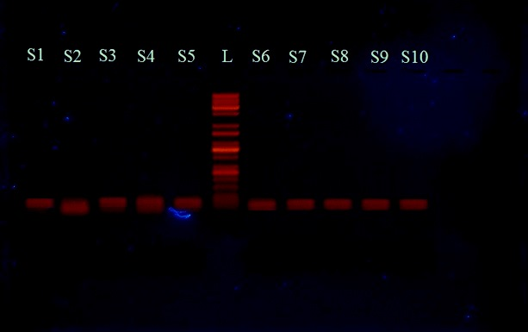
Figure (2) Gel electrophoresis stained with ethidium bromide of DNA fragment
that obtained from skin lesion suspected infection with cutaneous leishmaniasis. L: ladder, (KAPABIOSYSTEM Company, USA); S: sample.
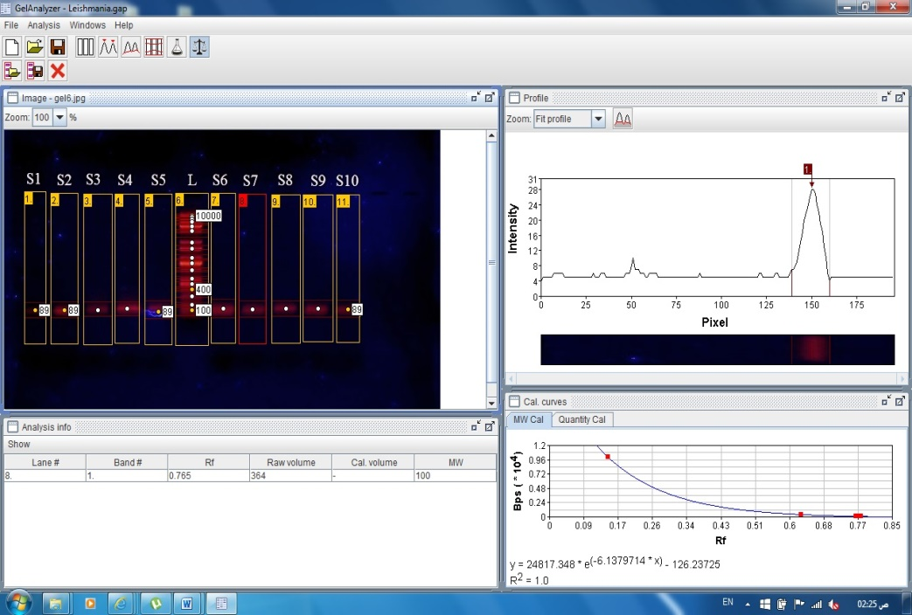
Figure (3): gelanalyzer software shows the molecular weight of bands of Leishmania
parasites DNA. The molecular weight of Samples (S1, S2, S5, S10) is 89 base pair (bp)
and the other remaining samples was 100 bp.
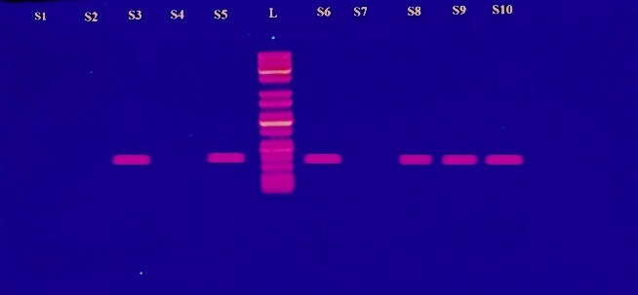
Figure (4) Gel electrophoresis stained with ethidium bromide of DNA fragment
that obtained from PCR assay with specific primers to detect Leishmania
tropica species. L: (ladder, (KAPABIOSYSTEM Company, USA) S: sample.

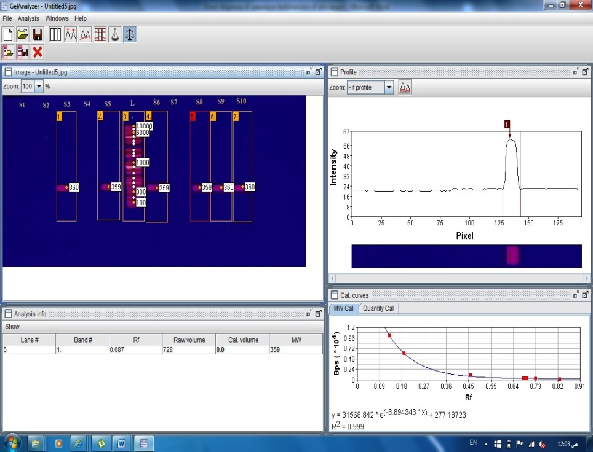
Figure (5): gelanalyzer software shows the molecular weight of bands of Leishmania tropica
DNA. The molecular weight of Samples (S3, S5, S6, S8, S9, S10) approximately
359- 360 bp.
The microscopic examination of fresh staining samples shows eight samples of ten was positive and the other was negative figure (2).
The sensitivity of this test was 80% $\frac{True positive (8) }{True positive \left(8\right)+False negative(2) } x 100=80\%$ this result agreement with suggestion of (25) about sensitivity of direct diagnosis of leishmaniasis by detection of LD bodies in fresh staining samples.

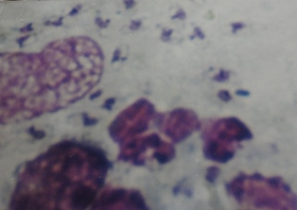
Figure ( 6 ) Direct examination of staining specimen from skin lesion, showed amastigotes of Leishmania spp. ( LD bodies). (Giemsa stain 100 x).
The median time required to obtain a positive culture from skin lesion in cutaneous leishmaniasis was seven days, but the initial examination of culture at third days and repeated to other day till fifteen days specially negative culture; eight samples appear to be positive the sensitivity of this test was 80% ($\frac{True positive (8) }{True positive \left(8\right)+False negative(2) } x 100=80\%$), this agreement with (26), when determine the sensitivity of this test vary from 60-80% .
The parasite culture is feasible method for the detection of Leishmania parasite in field conditions and the combination of culture and PCR has a potential role for the diagnosis of cutaneous leishmaniasis in candidates for clinical trials (27).
REFERENCES

1. Desjeux, P. (2001). The increase in risk factors for leishmaniasis worldwide. Trans R Soc Trop Med Hyg;95:239–243.
2. Alvar, J. ; Croft, S. and Olliaro, P.( 2006). Chemotherapy in the treatment and control of leishmaniasis. Adv Parasitol. 61 : 223–274.
3. Gabriele, S. ; Abedelmajeed, N. ; Nicole, D. ; Carlo, S. ; Henk, D. ; Schallig, F. H. Wolfgang, P. and Charles, L. J. (2003). PCR diagnosis and characterization of Leishmania in local and imported clinical samples. Diag. Micro. and Inf. Dis. 47,349–358
4. Rioux, J. A. ; Lanotte, G. ; Serres, E. ; Pratlong, F. ; Bastien, P. and Perieres J. (1990).Taxonomy of Leishmania. Use of isoenzymes. Suggestions for a new classification. Ann Parasitol Hum Comp; 65 (3) : 111-125.
5. Vega Lopez, F. (2003). Diagnosis of cutaneous leishmaniasis. Curr Opin Infect Dis
;16:97–101.
6. Profeta, M. Z. ; Rotondo da Silva, A. ; Oliveira, F. S. ; Caligiorne, B. R. ; Oliveira, E. and Rabello, A. (2009). Lesion aspirate culture for the diagnosis and isolation of Leishmania spp. from patients with cutaneous leishmaniasis. Mem Inst Oswaldo Cruz Rio de Janeiro;104:62–66.
7. Chargui, N. ; Bastien, P. ; Kallel, K. ; Haouas, N. ; Akrout, F.M. ; Masmoudi,
A. , Zili, J. ; Chaker, E. ; Othman, A.D. ; Azaiez, R. ; Crobu, L. ; Mezhoud, H. and Babba, H. (2005). Usefulness of PCR in the diagnosis of cutaneous leishmaniasis in Tunisia. Trans. R. Soc. Trop. Med. Hyg. 99, 762—768.
8. Maurya, R. ; Singh, R.K. ; Kumar, B. ; Salotra, P. ; Rai, M. and Sundar, S. (2005). Evaluation of PCR for diagnosis of Indian kala-azar and assessment of cure. J. Clin. Microbiol. 43, 3038—3041.
9. Oliveira, J.G. ; Novais, F.O. ; de Oliveira, C.I. ; da Cruz Junior, A.C. ; Campos, L.F. ; da Rocha, A.V. ; Boaventura, V. ; Noronha, A. ; Costa, J.M. and Barral, A. (2005). Polymerase chain reaction (PCR) is highly sensitive for diagnosis of mucosal leishmaniasis. Acta Trop. 94, 55—59.
10. Lemrani, M. ; Hamdi, S. ; Laamrani, A. and Hassar, M. (2009). PCR detection of Leishmania in skin biopsies. J Infect Developing Countries;3:115–122.
11. Richard, R. ; Jean-Claude, D.(2006). Molecular diagnosis of leishmaniasis: Current status and future applications. J Clin Microbiol;45:21–25.
12. Al-Alousi, T. I. ; Katif, B. M. and Al-Shanawi, F. A. (1980). Detection of antibodies to leishmaniasis in dried blood on filter paper by the indirect
fluorescent antibody technique. Ann Trop. Med. Parasitol.; 74 : 503- 506.
13. Osman, A. ; Kopper, B. A. ; Barrios, F. X. ; Osman, J. R. and Wade, T. (1997). The Beck Anxiety Inventory: reexamination of factor structure and psychometric properties. Journal of Clin. Psycho., 53(1), 7–14.
14. Meredith, J. E. ; Fazeli, B. and Schwartz, M. A. (1993). The extracellular matrix as a cell survival factor. Mol. Biol. Cell, 4,953-961.
15. Marfurt, J. ; Niederwieser, I. ; Makia, N. D. ; Beck, H. P. and Felger, I. (2003). Diagnostic genotyping of Old and New World Leishmania species by PCR-RFLP. Diagn. Microbiol. Infect. Dis. 46:115-124.
16. Milan, J. ; Eva, Z. ; Al-Jawabreh, A. ; Gabriele S. and Julius L. (2006). Development of a direct species-specific PCR assay for differential diagnosis of Leishmania tropica. Diagnostic Microbiology and Infectious Disease 55 , 75–79.
17. Nouri, L. and Al-Jeboori, T. (1973). Kala-azar in Iraq, an epidemiological and clinical study. J. Fact. Med. Baghdad, (15) : 72-85.
18. Eva, H. ; Gerald, K. ; Alejandro, B. ; Betzabé, R. and Nina, A. (1998). Single-Step Multiplex PCR Assay for Characterization of New World Leishmania Complexes. J Clin Microbiol. 36(7): 1989–1995.
19. Noyes, H. A. ; Reyburn, H. ; Bailey, J. W. and Smith, D. (1998). A nested-PCR–based schizodeme method for identifying Leishmania kinetoplast minicircle classes directly from clinical samples and its application to the study of the epidemiology of Leishmania tropica in Pakistan. J Clin Microbiol, 36:2877– 2881.
20. Zemanova, E. ; Jirku, M. ; Mauricio, I. L. ; Miles, M. A. and Lukes, J. (2004). Genetic polymorphism within the Leishmania donovani complex: Correlation with geographical origin. Am J Trop Med Hyg 70:613– 617.
21. Weigle, K. ; Labrada, L.A. ; Lozano, C. ; Santrich, C. and Barker, D. (2002). PCR-based diagnosis of acute and chronic cutaneous leishmaniasis caused by Leishmania (Viannia). J Clin Microbiol 40: 601–606.
22. Anders, G. ; Carol L. ; Eisenberger, F. J. and Charles L. G.(2002). Distinguishing Leishmania major and Leishmania tropica in the Middle East using the polymerase chain reaction with kinetoplast DNA-specific primers. Trans. Roy. Soci. of Majorl Med. Hyg; 96 : 87-92.
23. Schfnian, G. ; Schnur, L. F. ; El Fari, M. ; Oskam, L. ; Kolesnikov, A.A. ; Sokolowska-Kohler, W. and Presber, W. (2001) . Genetic heterogeneity in the species Leishmania tropica revealed by different PCR-based methods. Trans R Soc Trop Med Hyg 95:217–224.
24.Schfnian, G. ; Nasereddin, A. ; Dinse, N. ; Schweynoch, C. ; Schallig, H.D.F.H. ; Presber, W. and Jaffe, C. L. (2003). PCR diagnosis and characterization of Leishmania in local and imported clinical samples. Diagn Microbiol Infect Dis 47:349– 358.
25 . Brustoloni , Y. M. ; Rosimar B. L. ; Rivaldo V. ; Maria, E. D. ; Elisa, T. O. ; Ana Lúcia, L. D. and Claude, P. (2007). Sensitivity and specificity of polymerase chain reaction in Giemsa-stained slides for diagnosis of visceral leishmaniasis in children. Mem Inst Oswaldo Cruz, Rio De Janero, 102(4) .
26. Singh, S. ; Dey, A. and Sivakumar, R. (2005). Applications of molecular methods for Leishmania control. Rev. Expert. Rev. Mol. Diagn; 5: 251-65.
27. Ampuero, J. ; Rios A. P. ; Carranza-Tamayo, C. O. and Romero, G.A. (2009)
Genus-specific kinetoplast-DNA PCR and parasite culture for the diagnosis of localised cutaneous leishmaniasis: applications for clinical trials under field conditions in Brazil. Mem Inst Oswaldo Cruz. Nov;104(7):992-7.

